The Second Grade Scoop
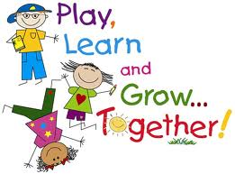
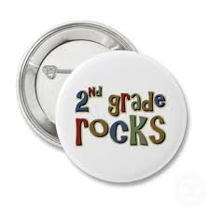
Mrs. Carie Aslor – caslor@psdschools.org, Mrs. Erin Bledsoe – ebledsoe@psdschools.org & Mrs. Susan Fitzpatrick – susanf@psdschools.org
Monday  SPECIALS  Aslor: Music & Art  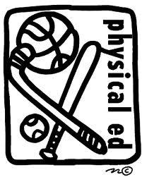  Fitz: PE & Music  Bledsoe: Art & PE  Important Dates:  12/18 – Denver Museum of Nature & Science – presentation on digestive system  12/19 – Dr. Ward – presentation on teeth and oral care  12/21 – Responsibility Awards Assembly @ 8:45  12/21 – Holiday Party  12/24 – 31 – Winter Break  1/7 – No School  1/11 – Report Cards go home | Tuesday  SPECIALS  Aslor: PE & Tech  Fitz: Art  Bledsoe: Music & Tech  Reading  Along with completing our 3 rotations of Daily 5, we do several mini-lessons each day. The students know these lessons as brain breaks and we do them in-between each rotation. These mini-lessons focus on grammar, spelling, vocabulary and reading strategy skills. This week some of the skills that we have been learning include:  - multiple-meaning words  - past-tense verbs  - authors purpose | Wednesday  SPECIALS  Aslor: Music & Lib  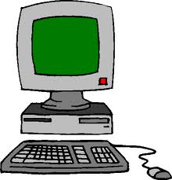  Fitz: PE & Tech  Bledsoe: Art  Writing  We are continuing to teach, model and write summaries. Students are having lots of opportunities to practice summary writing. They can start using the tricks we are teaching them to summarize books for their seed journals. | Thursday  SPECIALS  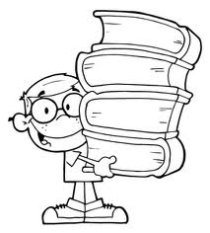  Aslor: Art  Fitz: Music & Lib  Bledsoe: PE & Tech  Math  In math we continue to work on addition and subtraction facts. We have introduced the traditional ways of carrying and borrowing. Continue to practice these skills at home. We are recognizing that patterns help us solve math problems both on paper and mentally. We have been challenging the kids with higher level mental math problems (25+10-6+3+18-10=?). They have really enjoyed it and are quite accurate in their calculations. | Friday  SPECIALS  Aslor: PE & Tech  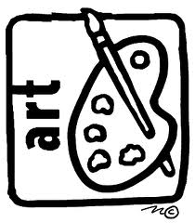  Fitz: Art & Tech  Bledsoe: Music & Lib  CORE  This week we started learning about the human body. We experimented with food as we recreated a cell and explored our taste buds - sampling sweet, sour, salty and bitter liquids. We are also learning about the digestion system and the food plate. Next week we will have two presentations helping us learn more about the human body.

