The Second Grade Scoop
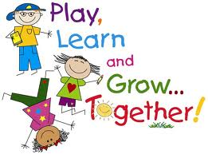
Mrs. Carie Aslor – caslor@psdschools.org, Mrs. Erin Bledsoe – ebledsoe@psdschools.org & Mrs. Susan Fitzpatrick – susanf@psdschools.org
Monday  SPECIALS  Aslor: Music & Art  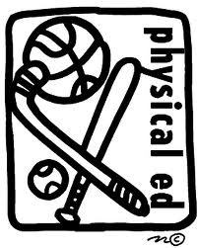  Fitz: PE & Music  Bledsoe: Art & PE  Important Dates:  12/11 – 2nd grade music program @ 5:30 Midtown Arts  12/14 – 2nd grade music program @ 9:15 Bethke  12/21 – Responsibility Awards Assembly @ 8:45  12/24 – 31 – Winter Break  1/7 – No School  1/11 – Report Cards go home  Lettuce Be Healthy  From Dec. 3 – 14 we are encouraging students to eat and try new vegetables in the cafeteria. Each student who tries/eats 3+ vegetables will receive a raffle ticket. We will be having daily raffles during those 2 weeks. Students who bring home lunch can also participate! The Wellness Committee is looking for parents to help pass at raffle tickets at lunch. If you typically eat with your child and could come 20 minutes early to help or stay 20 minutes late to help that would be appreciated. Here is a link to the google doc to sign up:  https://docs.google.com/a/psdschools.org/document/d/154A33gu_PmErVPb23nxcVDxztnVqz6Ntt0aEwdKjcqg/edit?pli=1  (Sorry you will need to copy/paste it.) | Tuesday  SPECIALS  Aslor: PE & Tech  Fitz: Art  Bledsoe: Music & Tech  Reading  We have found a link this week that is a book review of the Daily 5. It has some great information about the program and what research says about it. It also shares some of the information in the book about picking a good fit book, three ways to read a book, and some coaching strategies you can use at home.  http://www.thedailycafe.com/public/1871.cfm | Wednesday  SPECIALS  Aslor: Music & Lib  Fitz: PE & Tech  Bledsoe: Art  Writing  We are starting a unit on writing summaries. Summaries are very different from a retell. A retell gives lots of information about a story, where as a summary is a short quick paragraph giving less information. A retell is often only done orally. | Thursday  SPECIALS  Aslor: Art  Fitz: Music & Lib  Bledsoe: PE & Tech  Math  We will be starting unit 6 this week. In this unit we will be reviewing strategies for solving addition problems especially those having three addends, solving comparison number stories & completing the correct diagram to solve either an addition or subtraction problem. We will introduce and practice the trade first subtraction algorithm. | Friday  SPECIALS  Aslor: PE & Tech  Fitz: Art & Tech  Bledsoe: Music & Lib  CORE  We have been studying about simple machines. We will have the opportunity to build some simple machines using our K’nex simple machine kits. This is a great hands-on experience that the kids really enjoy. Thanks for all your direction in building their catapults. We will be shooting them next week. After simple machines we will start the human body – digestive system.

