The Second Grade Scoop
Mrs. Carie Aslor – caslor@psdschools.org, Mrs. Erin Bledsoe – ebledsoe@psdschools.org & Mrs. Susan Fitzpatrick – susanf@psdschools.org
Monday  SPECIALS  Aslor: Music & Art  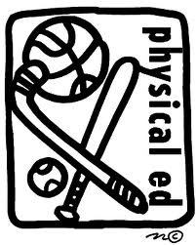  Fitz: PE & Music  Bledsoe: Art & PE  Important Dates:  10/ 12 - PTO Social  10/15 – Vision and hearing screening  10/16 – Report Cards go home  10/18 - 10/19 - NO SCHOOL  10/16 – 10/18 – Parent Teacher Conferences  Note:  We are looking for parents who can help with bulk projects related to our core units. Projects include cutting construction paper, making copies on the rizo, etc. Please contact your child’s teacher if you are able to help. | Tuesday  SPECIALS  Aslor: PE & Tech  Fitz: Art  Bledsoe: Music & Tech  Reading  We now have added all the components of our Daily 5 routine. I am conferencing with students. We are working together to declare a goal that they will be working on in reading. | Wednesday  SPECIALS  Aslor: Music & Lib  Fitz: PE & Tech  Bledsoe: Art  Writing  We are continuing to work on our student paragraphs. Along with this we are looking at connecting two ideas together in a sentence. We also continue to talk about our topic sentences, periods, capitals, transition words, and conclusions. | Thursday  SPECIALS  Aslor: Art  Fitz: Music & Lib  Bledsoe: PE & Tech  Math  We are towards the end of Unit 2 in our math book. We will finish up with strategies for subtraction problems. Unit 3 will focus on place value, money and time. A great focus for home is practicing counting money and telling time to the nearest five minutes. | Friday  SPECIALS  Aslor: PE & Tech  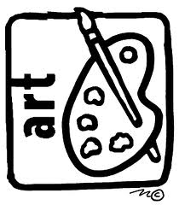  Fitz: Art & Tech  Bledsoe: Music & Lib  CORE  Last week we concluded our units on the Constitution and the War of 1812. We enjoyed working collaboratively to recreate all the United States flags, past to present. This week we will start our unit on the Civil War.

