The Second Grade Scoop
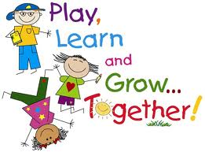
Mrs. Carie Aslor – caslor@psdschools.org, Mrs. Erin Bledsoe – ebledsoe@psdschools.org & Mrs. Susan Fitzpatrick – susanf@psdschools.org
Monday  SPECIALS  Aslor: Music & Art  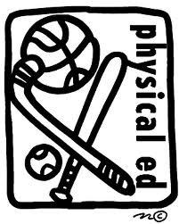  Fitz: PE & Music  Bledsoe: Art & PE  Important Dates:  9/17 – No School (Collaboration Day)  9/20 – Picture Day  10/12 – PTO Social  10/16 – 18 - Conferences  Note:  A Friday folder email has been going home every Friday from bethkefridayfolder@gmail.com.  If you are not receiving this email please check your spam or junk mail and add to your contacts. If it is not there send an email to let them know. | Tuesday  SPECIALS  Aslor: PE & Tech  Fitz: Art  Bledsoe: Music & Tech  Reading  This week in reading we have been working hard on getting our Daily 5 routine in place. Things are going well. We are having fun picking out what kinds of books we like and reviewing how to take an AR test. We have also started reading our Treasures stories. | Wednesday  SPECIALS  Aslor: Music & Lib  Fitz: PE & Tech  Bledsoe: Art  Writing  In writing we have been working on brainstorming and webbing things we know about a specific classmate. We then have turned that information into paragraph form, talking about capitals, periods, and indenting. We will make a book for everyone in our class. | Thursday  SPECIALS  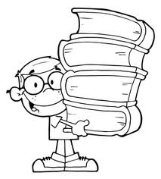  Aslor: Art  Fitz: Music & Lib  Bledsoe: PE & Tech  Math  We have finished with Unit 1 which was a review of skills from first grade. We have started Unit 2 where we will look at +1 and +0 addition facts, fact families, and addition stories. We will also learn about ounces and pounds. | Friday  SPECIALS  Aslor: PE & Tech  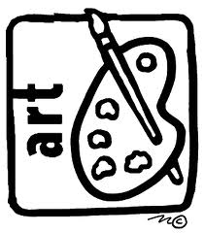  Fitz: Art & Tech  Bledsoe: Music & Lib  CORE  This is the last week of Geography and Map skills. We are creating a report about a specific state. Our next core unit will be the Constitution and the War of 1812.

